PITSTONE PARISH COUNCIL
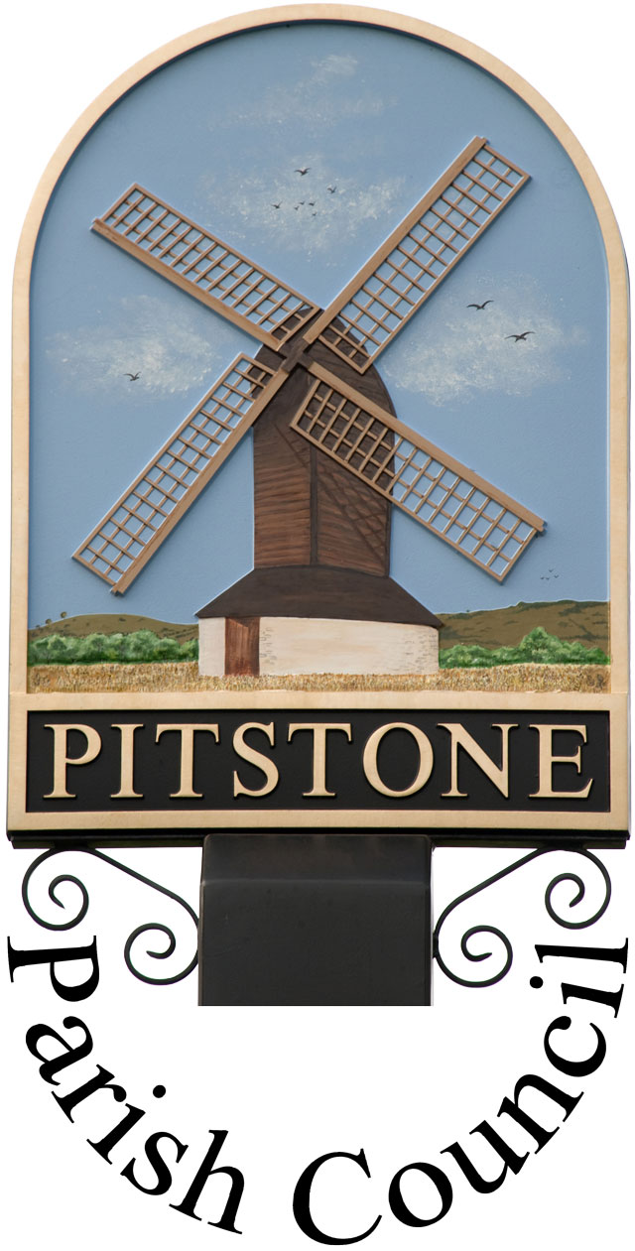

9 Warwick Road, Pitstone, Beds, LU7 9FE
Tel: 01296 660791. Email: parishclerk@pitstone.co.uk
Facebook: Pitstone Parish Council Twitter: @pitstone_pc
Web site: www.pitstone.co.uk
VAT registration number: 944 4611 21

Community Engagement Strategy

Purpose

The purpose of community engagement is to effectively involve people in the decision-making processes and work of the Parish Council. It will give a voice to local people as individuals, as well as community groups, public bodies, businesses, and anyone with an interest in the Council’s services and projects. Engagement is a two-way process, which allows the public to talk to the Council about their views and needs, and in return enables the Council to tell the community about its work, its priorities and how well it is performing.

The aim of the strategy is to provide opportunities for people to participate at whatever level they wish in order to influence the Council’s service delivery, priorities and policies.

Effective community engagement will help to clearly identify the needs of local people, empower the community in local decision-making, and create a greater level of interest in, and understanding of, local government.
This policy applies primarily to the Parish Council, although elements may be utilised by the Recreation Ground Charity and Pitstone Parish Charity where appropriate.

Legislation

The Local Government and Public Involvement in Health Act (2007) places emphasis on the importance of effective engagement with the community and facilitating inclusive and effective participation by individuals and organisations in local governance.

Our Commitment to Community Engagement

The Parish Council has three main aims of:

- representing the local community
- delivering services to meet local needs, and
- striving to improve quality of life in the parish.

So community engagement is key at many levels including:

  - Consultation with residents, including parish-wide surveys when necessary,
  - Representation on local voluntary organisations to assess how well current services meet residents’ needs, understand how those needs are changing and respond effectively to those changes
  - Consult with and respond to District Council, County Council and other Authorities on current services and planned changes, to ensure continuing improvement in services consistent with local needs
  - Encourage and assist community and voluntary organisations that improve conditions for or offer services to the residents of Pitstone

Engagement Mechanisms

The Parish Council will engage with its community using the following methods:

- Provision of information to the community

We have adopted the Information Commissioner’s Office “Model Publication Scheme”, which commits the Council to producing and publishing the method by which specific information will be made available, so that it can be easily identified and accessed by the public. As a result, we publish the “Guide to Information Available from Pitstone Parish Council”, which explains what information is routinely available and how it can be accessed.

Council and committee agendas and minutes are made available on www.pitstone.co.uk, and links also published via Facebook and Twitter and on our notice-boards.

We produce four issues of Pitstone Parish Post magazine per year, which is delivered free-of-charge to every home in the parish and published on the website.

Press releases are sent to Leighton Buzzard Observer and Bucks Herald, as well as being published on the web site and flagged up through our social media accounts.

Where the circumstances are appropriate, we may produce a leaflet and deliver to all residents in the parish.

- Enabling the community to comment

Councillor contact details are available on the web site and are published in Pitstone Parish Post as well as displayed on the notice-boards.

Residents are welcome to email us on parishclerk@pitstone.co.uk and we can be contacted via our Twitter feed and Facebook page as well as the more traditional post and telephone.

There is a period set aside for public questions at the beginning of every meeting of the full Council and committee meetings as well as within the Annual Parish Assembly.

We have formal councillor representation on a wide range of charitable and outside bodies, as well as working in partnership with agencies such as Aylesbury Vale District Council, Buckinghamshire County Council, Thames Valley Police and the Environment Agency.

Our annual external audit provides an opportunity for the public to ask questions about our Statement of Accounts and Balance Sheet.

We carry out targeted consultation to ascertain people’s views on specific topics as and when the need arises, in order to avoid consultation fatigue. This may take the form of electronic surveys, printed surveys, community engagement days, stands at community events, attendance at particular groups etc.

Standards for Engagement

The Parish Council will adhere to the following standards:

- Inclusion
- Use plain language
- Take into account the particular needs of people, especially in hard-to-reach groups, to enable them to participate
- Listen to, and respect, all opinions received

- Clarity and Transparency
- Be clear about what we are asking the public to comment on when seeking people’s views
- Only use engagement and consultation processes when there is a real opportunity for people to influence decision-making and services
- Provide feedback whenever possible

- Visibility
- Ensure that those directly affected by decisions, policies and plans are aware of the opportunity to engage

Responsibility

The success of this strategy lies with all councillors, who actively work to enhance community engagement in Parish Council decision making and the Parish Clerk who is responsible for overseeing its implementation.

Review

This Community Engagement Strategy was adopted by Pitstone Parish Council on
.............................................. minute reference ................................................ and will be
reviewed on at least an annual basis.

Signed on behalf of Pitstone Parish Council by:

___________________________________________
Chairman

