1st Ivinghoe & Pitstone
‘Scout Christmas Post’ 2014


1st Ivinghoe & Pitstone
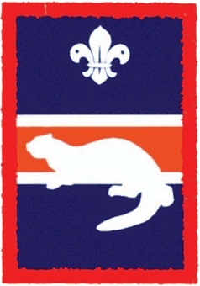 15p Scouts Christmas Post 2014
1st Ivinghoe & Pitstone
15p Scouts Christmas Post 2014

This Christmas why not support your local Scouts and save yourself some time posting Christmas cards around Ivinghoe, Pitstone and Marsworth by using the Scout Christmas post instead?

You can buy our special Scout stamps, at 15p each, from the local venues below from 28th November onwards. Stick them on your cards and post them in one of our many special post boxes – locations also below.

We will ensure that all cards posted by the ‘last post’ (5pm on Friday 19th December) will be delivered across the weekend of 20th/21st December 2014.

You can buy stamps at: |  | Post your Christmas cards at:
Pitstone |  | Pitstone
Masons Stores |  | Masons Stores
Ivinghoe |  | Ivinghoe
The Rose and Crown pub |  | The Rose and Crown pub
CuriosiTEA Rooms |  | CuriosiTEA Rooms (Ivinghoe Old School)
(Ivinghoe Old School) |  | St Mary’s Church
Marsworth |  | Marsworth
The Red Lion pub |  | The Red Lion pub

We can only cover the villages of Ivinghoe, Pitstone and Marsworth.
Please write addresses legibly – if we can’t read it, we can’t deliver it!

Thank you for your support in advance.
Also a big thank you to all the venues helping us to sell stamps and collect your post. All monies raised will support scouting in our villages.
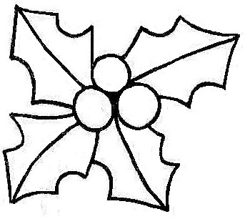 Scouts and Leaders of 1st Ivinghoe & Pitstone Scout Group

