Pitstone Water Mill Circa 1982
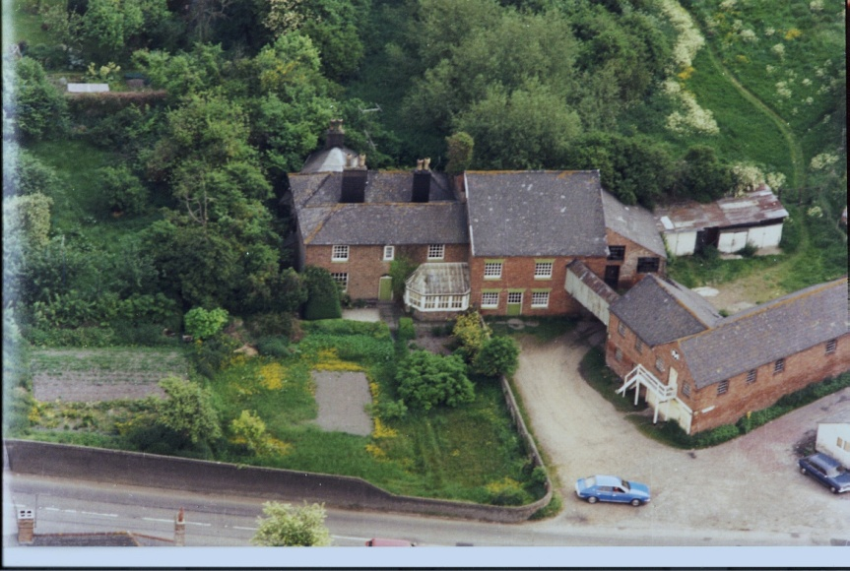
History of Pitstone (Brook End) Mill
There has always been some debate as to whether this building stands in Ivinghoe or Pitstone, this is because the Whistle Brook which represents the Parish Boundary used to run directly under the building, but it is generally agreed that it is in Pitstone.
The current building is relatively modern in appearance and it seems that most of the current structure was built in 1866, on the site of a pre-existing Mill which occupied this very ancient site. It has been known overtime as, The Old Mill, Griffins Mill, Pightlesthorn Mill, and Beesley's Mill ( after Francis Beesley, who resided at the mill for more than 60 years) It is has now been turned into a residential property called Brook End Mill.
Most of our members will know that there has always been a deal of confusion regarding the various Watermills in and around Ivinghoe and Pitstone. This is because 12th and 13th century documents fail to identify the exact location of any Watermills referred to. We can however say categorically that this is a very ancient site.
The earliest reference to a mill in Pitstone is 1215 when the bishop of Winchester bestowed it on Ralph of Ivinghoe, he was at the time the Chancellor of St Pauls Cathedral. It is believed by some that the sarcophagus on the left of the alter at St Marys Church Ivinghoe is his.We know that later Pitstone Mill was held on “behalf of the King” in 1530 by William Cowper (this would have been in the reign Henry V.III, who around that time was stage managing his divorce from Catherine of Aragon).
Pitstone Windmill (dated 1627) has always been linked with Pitstone Mill. The two were connected by a “good road” then known as the Mill Way, and it followed the line of what is now Orchard Way. The Whistle Brook also known as the Missel Brook because of the propensity of fresh water mussels there in, was the source of power. Often in the past The Windmill, Pitstone Watermill and Ford End Watermill have often been worked simultaneously by the same individual’s, this is not surprising when you realize that as the crow flies they are all just a short walk away from each other.

In 1770 (at the start of the American War of Independence) the Mill House was occupied by John Burt a baker from Edolsborough who at the age of 21 married Spinster Elizabeth Clarke. We know from his will that John Burt was not a literate man. He signed his will by “making his mark” (a large X).
His intention was to bequeath the mill to his son John (junior) a baker who lived in a now disappeared building in Ivinghoe known then as the “Round House”. Due to the sudden illness of John (junior), John (the elder) was forced to rewrite his will in favour of James his other son. John (the younger) was fading fast in 1786 when he signed his own will as being “frail in body but sound of mind”. The Watermill and the Windmill fell to James. Related documents give a very good description of the property at that time. We know that the water wheel was overshot and that there were cress beds, a fishery and an orchard attached to the property. There is a list of chattels which include clothes, bed linen, furniture (a good bed) and pewter plate. The Land Tax Assessment for 1788 shows the “late John Burt” as renting numerous other properties in the area.
In 1789 James Burt (farmer, miller and baker) insured both of his mills (Wind & Water) with The Sun Fire Insurance Company. This included his dwelling, adjoining offices, utensils and stock for the princely sum of £400. By 1801 James had switched insurers to The Royal Exchange Fire Insurance Company, and the cover now included a “bake house” (the existence of which was verified when the owners of No 2 “The Millhouse” uncovered a substantial old fashioned iron bread oven hidden under plaster).
The property was described as being thatched and he “warrants” that there is no steam engine. This seems to imply that Watermills were changing to being steam driven and that these were perhaps considered an increased fire risk.
The 1798 Posse Commitatus (a document to assist in the mobilization of resources to feed the army in the event of French invasion) shows James as having 4 horses, 1Wagon, 4 carts and producing 20 sacks of flour a day.
In 1810 James Burt sold the mill at auction at the Rose & Crown Tring. The mill is described as having two set of stones and all the usual mill paraphernalia. The Windmill is reported as being a “capital building” and a piggery has been added, so the mill appears to have been prospering.
In 1813 (whilst Wellington was busy chasing Napoleon out of Spain), Mr William Buckingham, Steward of the Ashridge Estate, reported that in July that year he met with others at “Griffin's” Mill Pitstone, behind the Bell Public House to “perambulate the parish boundaries”. The BridgeWater Estate Map for 1821 also shows the mill as “Griffin's Mill” which confirms its name at that the time.
By 1823 (Kelly's Directory) shows Benjamin Anstee in residence, Benjamin was a church overseer and he was married to Jane (a widow). Aylesbury Reference Library contains many documents which relate to his business. There is an invoice from a bankrupt millwright, one William Cooper. It details a 12 foot diameter iron waterwheel, “built for Mr Anstee of Pitstone”.

The Tithe Map for 1838 (shortly after Queen Victoria came to Throne) shows the property as belonging to The Grand Junction Canal Company, but with Benjamin Anstee still in residence, which suggests that Anstee may have leased the property from the Brownlow Estate.
In 1842 the property was again advertised for sale but this time in the Aylesbury News. Francis Beesley the long term owner of the mill acquired it and set about developing the site. In 1849 a map by William Andrews shows “the new road to Pitstone”. (Previously the road took a somewhat circuitous right hand loop following alongside the Whistlebrook and joining up with the Northern end of Pitstone). This narrow lane was known as Gully Gut Lane and acted as the main thoroughfare between the two villages until the new Marsworth Road passing along the front of the Bell came into being. The the old lane still exists, its entrance is alongside the new flats adjacent to Brookmead School.
It was Francis Beesley who built the high wall (mostly now demolished) which surrounded the mill and its buildings. He maintained “it was to keep the devils out!”
Various directories of the time show that Beesley, continued to occupy the Watermill and the Windmill until 1850. A year prior to the “Great Exhibition” the Windmill was disposed of to the Bridge Water Trust. It was about then that the mill was converted to run on steam. This was not without hazard as can be seen from the diary of Mr Hart the local Headmaster who visited Beesley’s Mill on Friday the 2nd September 1864, to inspect the damage occasioned by the explosion of the boiler. This resulted in an unfortunate horse being blown across the yard and the bringing down of the chimney.
The damage to Mill may have been quite considerable since it seems to have triggered a complete rebuild. In his book on English Watermills Mr K. C. Reid refers to “Brook Mead” Watermilll, Pitstone, being rebuilt in 1866 “using timbers from the original mill”.
This solitary reference to a “Brook Mead” Mill in Pitstone, has led me to believe that this actually refers to Pitstone Mill. The proximity of the date of the explosion to the date of the rebuild and the location of the mill in an area known at the time as Brook Mead seems to support this conclusion. By way of further evidence many of the wooden beams within the mill are of great antiquity, and have numbers carved into them, something which usually indicates the re-use of old timbers.
The rebuilding complete Beesley continued in residence until his death in 1894 at the age of 75. The mill then passed to his wife Matilda and then to his daughter Sarah and it remained in the family until 1903 a total of 61 years in all.
In 1886 Thomas Robinson of Cholesbury recalled working in the mill as a lad. He describes four pairs of stone “three for wheat and one for barley” Thomas thought that the waterwheel was “breast shot” which does not tally with other evidence. He also confirms that Beesley had “an old beam engine” in the mill.

By 1903 the mill premises were extensive and comprised an array of outbuildings, a granary, a bake house and adjoining stables with cobbled floors. I have found very little information about the intervening years, except that a succession of Kelly’s Directories, show the mill as using “steam & water” for power and various millers at work. Mark Sharratt 1903, Jason Wright 1911, Henry Howlett (baker) 1915. The trail then goes cold but at some time in the intervening period the mill stopped milling. In 1938 it was sold with some surrounding land by Mr Frederick Jellis (duckbreeder) to Mr Edwin Horn (Motor Engineer).
From speaking to people who remembered Mr Horn he seems to have been a colourful character with an entrepreneurial bent. He actively purchased numerous cottages in Pitstone, ran the local garage, and provided (for a small fee) transport for villagers to Leighton Buzzard on market days.
Sometime in the late 1930’s the mill was visited by the doyen of all mill enthusiasts Stanley Freese. He was the one who coined the rather unkind description of the mill as being “not at all prepossessing and with an air of newness”. He describes the waterwheel as being overshot, 15ft in diameter with buckets 5 ft wide. Mr Horn showed him around recalling how he worked at the mill as a boy for just 4d a day. Freese says, that “at that point, the mill might still have been made workable”.
During the 2nd World War the Irish Guards were billeted in the Mill and Ivinghoe Youth Hostel, they added some out buildings which were used as a cook-house and for ablutions. Locals recall that there was a flag pole in the Mill yard.
Subsequent to the ending of the Second World War the Mill was used for a variety of purposes. At one stage a large London based Motorcycle Retailer stored excess stock there. There is a report that second hand furniture was stored there for a time, and that it was once used as chicken coop. The condition of the Mill was deteriorating although the granary fared better.
After the death of Mr Horn around 1956 the property came into the possession of Donald and Violet Howlett. Their son Alan still lives in the Mill House. For a number of years Mr Derek Curry ran a very successful drawing office located in the old Granary, and some very important Government Designs and drawings in relation to some famous cars and aero planes were produced here.
In 1989, the mill and outbuildings were sold to a property developer. He obtained planning permission to turn the Mill into a private residence and the Granary which was still standing at that time into Maisonettes. The housing slump of the late eighties intervened and the resulting financial difficulties meant work could not be completed which resulted in the National Provincial Bank taking over the property. The Granary had by this time been demolished and the Mill remained empty for a number of years until it was purchased by my wife and I who have lived there happily for the past 19 years.
Keith Russell
Membership Secretary, Ford End Watermill Society.
30/11/2009

