PITSTONE PARISH COUNCIL
9 Warwick Road, Pitstone, Beds, LU7 9FE
Tel: 01296 767261. Email: parishclerk@pitstone.co.uk
Facebook: “Pitstone Parish Council” and “Pitstone Youth”
Twitter: @pitstone_pc Web: www.pitstone.co.uk
______________________________________________________________________________

Privacy Impact Assessment Code of Practice

Introduction

Privacy impact assessments were launched in the UK by the Information Commissioner in December 2007 and mandated by the cabinet office for Information Communications Technology (ICT) projects following the Data Handling review in June 2008.

Purpose

The purpose of this document is to set out the process for completing Privacy Impact Assessments to identify any impact on privacy where a new service or system is introduced.

Scope

This policy applies primarily to the Parish Council, although elements may be utilised by the Recreation Ground Charity and Pitstone Parish Charity where appropriate.

This procedure is to be followed in the following circumstances:

- Introduction of a new information system to collect and hold personal data (consultation is seen as one of these purposes).
- Update or revision of a system that might alter the way in which the Council uses, monitors and reports personal information.
- Changes to an existing system where additional personal data will be collected, a proposal to collect personal data from a new source or for a new activity.
- Plans to outsource business processes involving storing and processing personal data.
- Plans to transfer services form one provider to another that include the transfer of information assets.
- Any change to or introduction of new data sharing agreements.
- Data sharing initiative where two or more organisations seek to pool or link sets of personal data.
- Any change to access of an information asset that involves an external organisation.
- Changes in legislation, policy or strategies which will impact on privacy through the collection of or use of information, or through surveillance or other monitoring.

Responsibility

Any person who is responsible for introducing a new or revised service or changes to an existing service, process or information asset is responsible for ensuring the completion of a PIA and therefore must be effectively informed of these procedures.

PIA Process

A PIA should begin early in the life of a project, before you start your processing, and run alongside the planning and development process. A PIA should incorporate the following steps (ICO, 2016):

- Identify the need for a PIA
- Describe the information flows
- Identify the privacy and related tasks
- Identify and evaluate the privacy solutions
- Sign off and record the PIA outcomes
- Integrate the outcomes into the project plan
- Consult with internal and external stakeholders as needed throughout the process

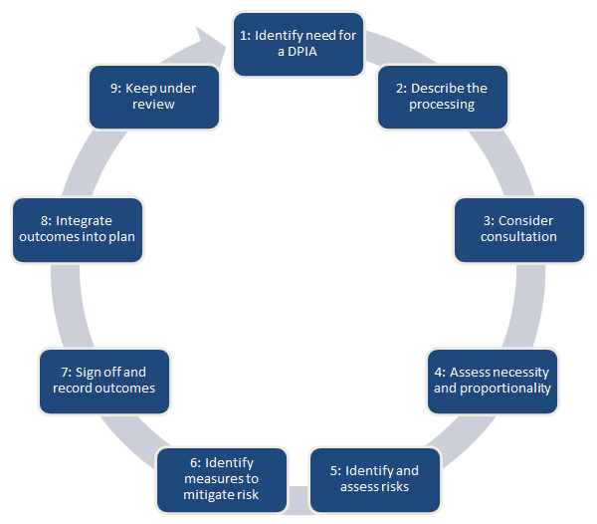

This Code of Practice must be used in conjunction with the information contained in the Parish Council’s Privacy Impact Assessment & Form.

Review

This Code of Practice was adopted by Pitstone Parish Council on
.............................................. minute reference ................................................ and will be
reviewed on at least an annual basis.

Signed on behalf of Pitstone Parish Council by:

__________________________________________
Chairman

