PITSTONE PARISH COUNCIL
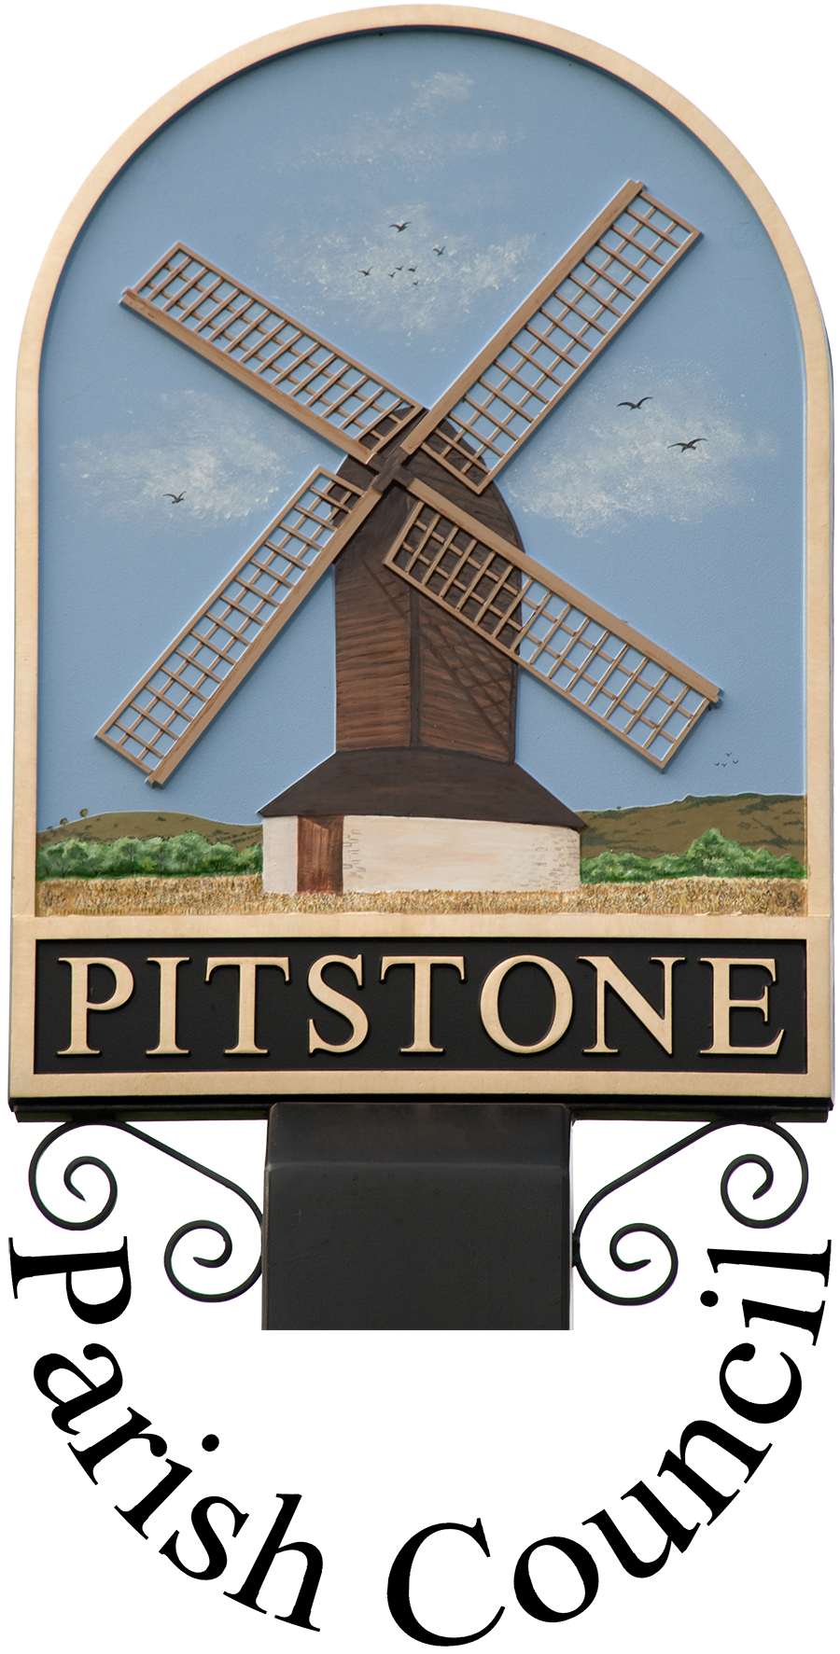
9 Warwick Road, Pitstone, Beds, LU7 9FE
Tel: 01296 767261. Email: parishclerk@pitstone.co.uk
Facebook: Pitstone Parish Council Twitter: @pitstone_pc
Web site: www.pitstone.co.uk
VAT registration number: 944 4611 21

Environmental Policy

Introduction

Pitstone Parish Council is committed to the creation of a sustainable community, balancing and integrating economic, social and environmental components. Developing a more sustainable community will benefit present-day residents and businesses, as well as future generations.

The Parish Council will investigate obtaining an Environmental Assessment of the Parish Council’s facilities and practices in order to provide an overview of environmental issues affecting the Council and consider the timing of any such report.

Legal Requirements

The main pieces of relevant legislation are:

- The Water Act 2003. This Act places a duty on all public bodies to consider, where relevant, the desirability of conserving water supplied or to be supplied to premises.
- The Natural Environment and Rural Communities Act 2006. From 1 October 2006, every public authority must, in exercising its functions, have regard, so far as it is consistent with the proper exercise of those functions, to the purpose of conserving biodiversity.
- Climate Change and Sustainable Energy Act 2006. This Act gives specific powers to town and parish councils to tackle climate change. The Act places an obligation on town and parish councils to improve their energy efficiency.
- Clean Neighbourhoods and Environmental Act 2005. This Act extends the statutory offence of dropping litter and enables town and parish councils to authorise officers to serve fixed penalty notices for the litter offence under section 88 of the 1990 Environmental Protection Act; gives town and parish councils the power to issue fixed penalty notices for graffiti and fly-posting offences; and allows town and parish councils to create offences relating to the control of dogs and replaces the Dogs (Fouling of Land) Act 1996.
- Duty of Care (Waste). This covers any business that produces or disposes of waste and requires the business to ensure that any waste produced is handled safely and in accordance with the law.
- Water Framework Directive. The purpose of the WFD is to establish a framework for the protection of inland surface waters, estuaries, coastal waters and groundwater. More information available here: http://www.wrse.org.uk/
- Agenda 21. 150 countries, including the UK, endorsed Agenda 21 at the 1992 UN Conference on Environment and Development. Chapter 28 of Agenda 21 calls for local authorities to initiate Local Agenda 21 processes. Local Agenda 21 involves taking a partnership approach to develop an action plan for sustainable development at a local level.
- Bucks & Milton Keynes Biodiversity Action Plan. It should be noted that this Action Plan covers Pitstone. The aim of the Biodiversity Action Plan (BAP) is to conserve and enhance the county’s wildlife habitats and associated species as a contribution to conserving the diversity of life on earth. The most recent version of the plan “Forward to 2020: Buckinghamshire and Milton Keynes Biodiversity Action Plan” sets ambitious targets for increasing the area of priority habitats in the county by 2020 through habitat creation and restoration eg 100 ha of lowland calcareous grassland and 100km of hedgerows. Ashridge & Ivinghoe Beacon is one of the 23 Biodiversity Opportunity Areas where priority habitat creation work will be focused. The Plan acknowledges the role that town and parish councils must play in the management of green spaces and in promoting awareness and encouraging people to participate in local community initiatives for biodiversity. The reports are available here: https://bucksmknep.co.uk/projects/forward-to-2020-biodiversity-action/
Policy Coverage

This policy applies to the land and properties that Pitstone Parish Council owns and land that the Council manages or is responsible for.

Whilst the Parish Council may work with other landowners and encourage stewardship of their land in an environmentally responsible manner, we have no power to enforce such action on other landowners.

Policy Objectives

Pitstone Parish Council recognises that its activities will have some negative impacts on the environment. The aim of this policy is to establish broad objectives to enable the development of activities that will minimise negative effects on the general environment and work towards enhancing and protecting Pitstone’s immediate environs.

The council will aim to improve its environmental performance and influence improvement in Pitstone in the following ways:
- Use energy, natural resources and non-renewable resources efficiently and strive to minimise waste and pollution.
- Inform Pitstone’s residents of the Council’s environmental activities and respond and react to feedback.
- Support individual behaviour change in Pitstone’s residents, leading by example and supporting environmentally friendly activities.
- Support local businesses in the adoption of low-impact practices.
- Manage its land using environmentally friendly practices that will promote biodiversity and protect habitats.
Specific Environmental Actions

- Water.
  - Water will be used efficiently for Council activities and on Council premises, with automatic cut-offs installed wherever possible.
  - The parish council has planting schemes in our open spaces and parks that do not require watering.
  - Where sports pitches require watering, this is limited to periods during restoration where rainfall does not reach the required levels. No watering of pitches is carried out at other times of year.
  - The Council has installed water troughs on our allotment site, and their use is limited to the key growing season. We will continue to encourage tenants to reduce their water use where possible.
  - The Council will investigate water saving options during any development or new projects and incorporate measures identified as viable.
  - The Council will consider issues of water use, water run-off and water pollution when making recommendations on planning applications. The Council will support the use of Sustainable Urban Drainage Systems (SUDs) in new developments to reduce flooding risks, manage stormwater, minimise diffuse pollution from surface water runoff and help maintain groundwater levels.

- Development.
  - The Council will consider sustainability, environmental impact and biodiversity when commenting on planning applications in Pitstone and when developing or redeveloping any of its own buildings. The Council consider such issues when responding to consultations relating to the Local Planning Authority’s Local Plans.
  - The Council may lobby on the need for developing sustainable drainage in order to counteract incidences of flash flooding.
  - The Council will press for the use of planning obligations (Section 106 agreements) to promote sustainable development and mitigate environmental impacts resulting from developments.
- Climate Change and Energy Conservation
  - The Council will monitor its energy use and seek to improve upon energy efficiency within its buildings and assets by adopting energy-saving measures eg purchasing equipment with good energy ratings, where possible.
  - We will increase awareness of energy efficiency amongst employees and encourage energy-conserving behaviour eg switching off lights that aren’t needed and switching off equipment rather than using standby.
  - The Council will install motion detectors to lighting where appropriate to reduce usage and avoid lights being left on.
  - We will investigate the feasibility of sustainable supplies of energy to power its premises, at each renewal of contract.
  - The Council will continue to roll out more energy efficient LED lighting across our streetlight portfolio, reducing use of SOX, SON & PLT lanterns.
  - The Council will investigate energy saving measures and features during any development or new projects and include such measures where viable.
  - The Council will strive to become carbon neutral in line with government targets, currently 2050.
- Waste
  - The Council will minimise its waste production wherever possible, by reducing, repairing and reusing resources, and by recycling the waste its activities produce, where facilities exist.
  - Rubbish will be disposed of safely, following the correct procedures, and only licensed contractors will be used to deal with hazardous wastes.
  - The Council will incorporate the possibility of pollution in its risk assessment procedure and will use this system to minimise the risks and implement mitigation strategies.
  - Pitstone Parish Council will provide litter bins and dog bins around the village to help residents correctly manage their ambulatory waste, and will employ litter pickers to empty litter bins and collect refuse that may have been dropped in our open spaces and streets to avoid this damaging the countryside.
  - Members are encouraged to reuse paperclips/bulldog clips/plastic folders etc or to return them to the parish clerk for re-use.
  - The Council will install curb-side recycling and refuse facilities at the pavilion site when it is redeveloped and will investigate the possibility of providing other recycling services for residents where viable.
  - We provide support to Bucks County Council to pass along messages about their recycling services and provide information to new parish residents.
  - The Council recycles all toner cartridges used at its premises, we reuse and recycle wastepaper and cardboard, we send any postage stamps to charity and we recycle any other materials for which there are collection points within the village and encourage our residents to do likewise.
- Urban Environment
  - Using powers delegated from Buckinghamshire County Council as part of the ‘Devolved Services’ initiative, the Parish Council works to undertake specific highways works that contribute to the improvement of the environment. These include issuing hedge-cutting notices, graffiti removal and clearing fly-posted signs.
  - The Council will address and control instances of noise pollution where these relate to activities arranged by the Parish Council.
  - The Parish Council may choose to work with the District Council regarding the powers accorded to it through the Clean Neighbourhoods and Environment Act, to investigate fixed penalty notices for littering, graffiti and flyposting or the creation of offences relating to dog fouling.
- Transport and Rights of Way
  - The council will continue to encourage sustainable transport systems, promoting public transport and non-polluting modes of transport, such as cycling and walking.
  - As traffic congestion can significantly reduce air quality, which directly impacts upon human health, the Council all also press other tiers of government for the alleviation of traffic congestion and HGV traffic through Pitstone.
  - The Council will continue to investigate opportunities to implement the proposals to improve cycling and walking whilst reducing vehicle & HGV movements in the village, outlined within the Ivinghoe & Pitstone Safety Scheme.
  - The Council supports several aspirations within the Pitstone Neighbourhood Development Plan to help improve the cycle/pedestrian network both within the parish and to neighbouring parishes.
  - The Council runs a Community Car scheme to help residents access their health care appointments.
  - The Council is investigating the introduction of a Community Bus Scheme.
  - The Council promotes the West Midlands Trains Lift Share Scheme for Tring Train Station and the generic Car Share Schemes to residents.
  - We will continue to reflect the needs of residents when Buckinghamshire County Council consult on public transport changes.
  - We will continue to improve the facilities for public transport users via encouraging the installation of real-time information panels and by providing bus shelters.
  - Under ‘Devolved Services’ from Bucks County Council we will continue to maintain several stretches of Right of Way and will work with landowners to promote good maintenance of paths/stiles/gates that lie within their ownership, to encourage walking.
- Biodiversity and Green Spaces
  - The Council will, wherever possible, consider the conservation and promotion of local biodiversity in all its activities, but particularly regarding land management. The Council will seek to manage green spaces in a manner that promotes and protects biodiversity. The includes the management of invasive plants on its land and using planting schemes that exclude species known to be invasive in the SE of England.
  - The use of pesticides is to be avoided, environmentally friendly alternatives considered, but where necessary, must be undertaken in an environmentally responsible manner.
  - The Council is committed to providing information (where appropriate) or providing signposting to the relevant authorities, to assist local landowners in the control of invasive species, environmentally sensitive land management and biodiversity conservation.
  - The Council will protect and, where possible, enhance the quality of Pitstone’s natural environment and open spaces.
  - The Council will continue to seek to purchase land for open space and/or leisure where opportunities arise, and has already purchased the Local Green Space by The Crescent and the parcel of land adjoining the Village Green which houses the play equipment etc.
  - The Council will continue to seek recognised protection for quality open spaces where appropriate such as the Local Wildlife Site designation for the land off Westfield Road and the Local Green Space designation for the land by The Crescent.
  - We aim to make open space accessible wherever possible.
  - The Council will continue to promote the use of its allotments as a source of local food, helping to reduce the food miles consumed by Pitstone residents.
  - The Council may look to create bylaws if these are required to protect and conserve its green spaces.
  - The Council may organise biodiversity audits on its land where this might assist in the development of environmentally sensitive management plans.
  - The Council supports several biodiversity aspirations within the Pitstone Neighbourhood Plan including the creation of more green space and support for wildlife friendly verge management.
  - As part of our Pitstone Neighbourhood Plan composition process we also commission both Strategic Environmental Assessments and Habitat Regulation Assessments to provide information about the wider environment and ensure that the planning policies for the parish take these into account.
- Sustainable Procurement
  - The Council will strive to purchase renewable/recycled, environmentally friendly or low-impact and recyclable materials where viable, so long as the requirements for value for money and quality are met.
  - We will ban the use, by the Council or its contractors, of certain specified environmentally damaging products where an alternative product or method is available. These products are:
    - Ozone depleting chemicals
    - Tropical hardwood that is not certified independently as coming from a well-managed forest
    - Pesticides on the UK ‘Red List’ and EC ‘Blacklist’
  - The use of peat for soil amelioration will be avoided wherever possible.
  - Sourcing materials and services locally, where feasible, will reduce carbon emissions resulting from transporting produce. The Council will promote local produce and products within the community as appropriate, which will have the additional positive effect of supporting the local economy.
- Awareness, Lobbying and Partnerships
  - The Council will promote awareness of, and information on, environmental issues within the community. It will act as a voice for local environmental concerns to those agencies given statutory powers to tackle problems.
  - The Council will engage in partnership working within the local community, organisations and other tiers of local government on conservation projects as opportunities arise.

Review

This Environmental Policy was adopted by Pitstone Parish Council on ...9-1-20.........
minute reference ...262/19.1..... and will be reviewed on at least an annual basis.

Signed on behalf of Pitstone Parish Council by:

D Nicholls

________________________________________
Chairman

