Tring Linking Lives

For over a year the High Street Baptist Church in Tring and Linking Lives UK, a national befriending charity, have been in collaboration to combat loneliness and social isolation in Tring and the surrounding villages. Our original service concentrated on Tring, but it has now expanded to cover the surrounding villages in Hertfordshire and Buckinghamshire.
It was estimated, by the Campaign Against Loneliness that there were more than one million people in the UK who considered themselves to be lonely most of the time. This seems staggering in a place like Tring, where there always seems to be something going on. But the reality is that people can be lonely and isolated in a crowd, at work, or even with a large family.
This estimate was based on the state existing before the Covid19 lockdown. It’s obvious that most of us now know what social isolation feels like and most of us are looking forward to getting back to a level of normality, whatever that may look like. Sadly, many experts believe that many more people could be affected by loneliness as the lockdown eases. It is feared that large number may not find it easy to come out of lockdown, because of mental health problems, redundancy, changes in working patterns, and business failure, to name just a few causes.
Many people find themselves alone after their partner passes away or are isolated, due to illness or disability. There are, however, many reasons why people may find themselves socially isolated, not getting out or not see as many people as they would like.
It was estimated, before the lockdown, that there were likely to be around 1000 people in our area who feel lonely or isolated. It’s also important to realise that loneliness is not about being elderly or confined to your home because of health or mobility problems. It will definitely make loneliness more difficult, but anyone of any age can experience loneliness.
This is where Linking Lives comes in. We find a compatible volunteer, based on interests, geography and personality. Visits are then arranged at times convenient for the volunteer and “Link friend”. Our current service is telephone based, to meet the requirements of lockdown, but we are exploring a safe return to our full service as soon as the regulations and availability of services permits.
We are hoping to return to one to one befriending as quickly as possible, but our plans are to go much further if it’s the wish of the Link Friend. We plan to provide social events and activities which provide opportunities to get out and mix with others. They include Lunch Clubs, Games Afternoons, Coffee mornings Visits to local beauty spots, Theatre and Art events, Linking to local clubs and organisations. We hope to restart events for young Mothers, and a Youth Club. At High Street Baptist Church, we have several weekly and annual events that involve over 100 people - everyone is welcome and some like “Sausage Sunday” and the “Easter Egg roll” on Pitstone Hill are almost legendary.
Tring Linking Lives is seeking to provide a link between the identified “Link Friends” and all the wonderful opportunities provided by organisations in and around Tring and the Villages. We do a great deal in the area, but we will be trying to do much more and help people to get involved.
Linking Lives UK is the parent charity, based in Reading since 1998, and operates over 36 befriending schemes throughout the country. We are a Christian charity but our services or not dependant on a link friend or volunteer having a particular faith or any faith at all. Each scheme is designed to meet the needs of the area in which it is situated. The Tring scheme is designed to take account of the fact that much of the identified social isolation in the area occurs in much younger people than many expect. Currently for every older person referred to us we are getting two aged under 50.
We also focus on linking and connecting our Link Friends back into the community, so we really have a “befriending plus” scheme and move from home visiting to getting people connected with clubs and activities as quickly as possible.
Tring Linking Lives relies on volunteers to deliver our service. Volunteers do not need any special skills as they receive full training, support and advice for their role. They also provide references and receive the necessary criminal records checks (DBS) prior to beginning visits. If you would like to become a volunteer, If you know of someone who would benefit from having a regular visitor, or if you would like a visitor yourself, please give us a call. for more information or an application form Please contact Cliff Brown - Tring Linking Lives 89 High Street Tring HP23 4AB
Telephone 01442 824054 or 07305 257160
or
via the Tring Linking Lives Page of
Tringbaptistchurch.co.uk website

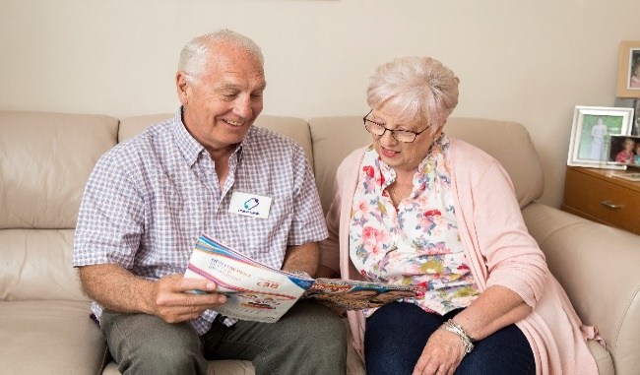

Cliff Brown Scheme Coordinator

