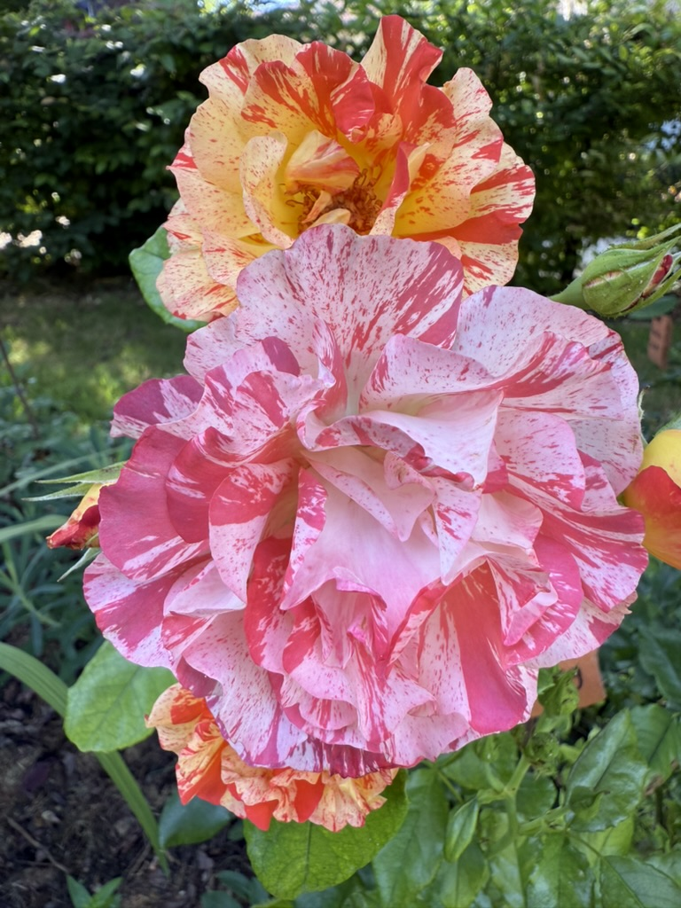

SATURDAY 9 AUGUST
The Ivinghoe, Ivinghoe Aston and Pitstone Horticultural Show

The Hub
Entrants from 9am (for more information please see forms)
Judging From 11am
Public viewing – 2-4pm

