Classes

Children’s Section
Age 5 and under and age 6 and over
1. A vase of weeds.
2. A miniature garden in a reusable seed tray using natural materials.
3. Egghead with watercress hair.
……………………………………….
These Sections are open
to ALL ages:
Vegetable Fruit & Produce
Section:

Vegetables
4. 5 coloured or white potatoes.
5. 3 onions - tops tied.
6. 5 shallots - tops tied.
7. 5 French beans -dwarf or climbing.
8. 3 carrots – tops trimmed to
75mm (3”).
9. 3 beetroot – tops trimmed to 75mm (3”).
10. 5 tomatoes.
11. 3 courgettes – 150mm-200mm (6”-8”) optimum length
12. 5 radishes – as pulled, roots
washed.
13. A bunch of 9 spring onions.
14. 5 runner beans
15. Longest runner bean
16. A pair of any other vegetable not listed above.
17. Collection of vegetables. No
limit on kinds or numbers, displayed in a box, basket or trug (maximum size 50cm (20”) in any dimension.
18. Bunch of culinary herbs.

Fruit
19. A dish of blackcurrants, red currants or whitecurrants, can be a single kind or mixed, displayed on a paper plate.
20. 3 sticks of Rhubarb – leaves
trimmed.
21. A dish of soft fruit (mixed) displayed on a paper plate.
22. Any other fruit not listed
above.

Plants and Flowers
Section:
Grown Flowers (see rules)
23. A specimen rose.
24. A vase of mixed annuals
25. 5 Dahlias.
26. Sunflowers – 3 stems.

Flower Arranging
27. A vase of weeds..

Cookery and Produce Section:

Cookery
28. A Victoria sandwich with
raspberry jam. (see recipe
overleaf)
29. 6 savoury muffins, own recipe to be cooked in muffin cases.
30. Shortbread - see recipe overleaf.
31. Fruit cake - see recipe overleaf.
32. A loaf of bread.

Produce
33. 6 eggs.
34. 3 tasty tomatoes.
35. 5 cooked homegrown salad potatoes.
36. Ugliest vegetable
37. A bottle of flavoured gin or vodka - max 500mls.
38. A jar of jam - see rules.
39. A jar of lemon curd - see rules.
40. A jar of marmalade - see rules.
41. A jar of savoury jelly - see rules.
42. A jar of chutney - see rules.

Craft Section:
43. A crochet or knitted flower.
44. A drawing or painting of a local scene.
45. A sewn cushion or garment – sewn by yourself either by hand or machine.
46. A label for a drinks bottle or jam jar.

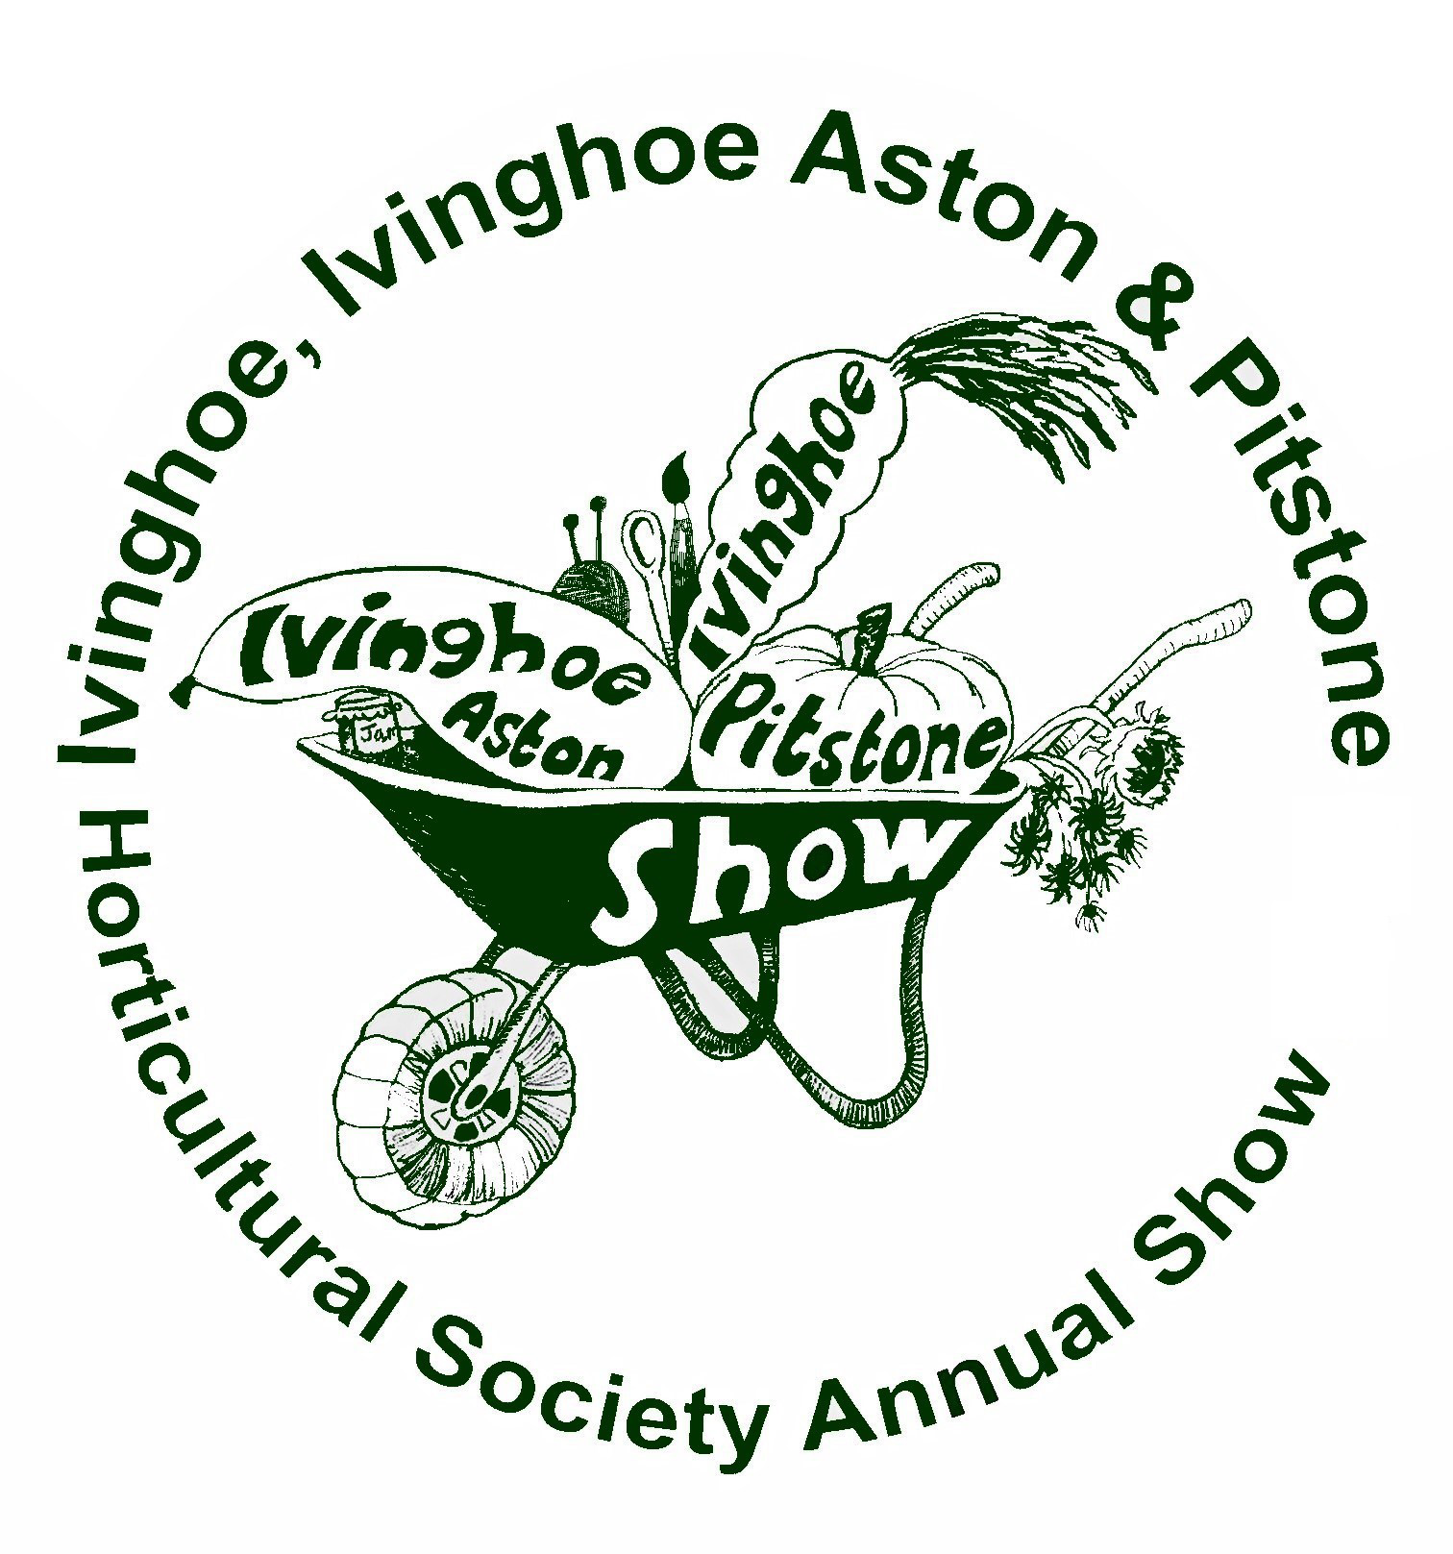

Parking will be open on The Lawn

Good Luck
with your entries

